# **Validation Report Cost-Obj**

## *Summary Report*

*OBJECT*

IfcSlab.BASESLAB

GlobalId: 1r$l67n5fDrxE0IVJzq9nz

Obj Name: Platea:FND_MGR_10:242936

*COST ITEM*

IfcCostItem

Price List Code: OC.EEA.a10.A6415.J0001.0025.-

GlobalId: 1TAfX5G4z1SegkfxOqK7Ng

Cost Name: Concrete casting for subfoundation layer C16/20_X0

*CHART*

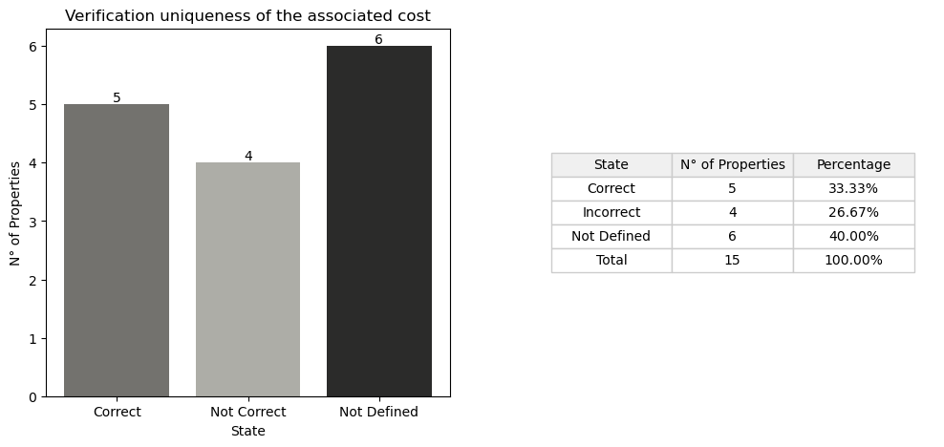

## *Detail Table*

|  |  |  |
| --- | --- | --- |
| **State** | **N° of Properties** | **Properties** |
| Correct | 5 | Entity TypeEnum LoadBearing ConstructionMethod StructuralClass |
| Incorrect | 4 | IsExternal StrengthClass ExposureClass ReinforcementVolumeRatio |
| Not Defined in the obj | 6 | ThermalTrasmittance AcousticRating FireRating Compartimentation Status ReinforcementStrengthClass |
| Not Defined in the cost | 1 | PitchAngle |
| Not Defined in the cost and obj | 0 |  |

## *Detail Report*

**🔸Number of Correct Properties: 5**

Entity: ✓   
 • #14=IfcSlab('2U8qiNAYP13B0Krl1VFWYj',$,'Sample element of concrete subfoundation slab','Sample element of concrete subfoundation slab',$,$,$,$,.BASESLAB.)   
 • #4334=IfcSlab('1r$l67n5fDrxE0IVJzq9nz',#21,'Platea:FND_MGR_10:242936',$,'Platea:FND_MGR_10',#4321,#4333,'242936',.BASESLAB.)   
  
TypeEnum: ✓   
 • #14=IfcSlab('2U8qiNAYP13B0Krl1VFWYj',$,'Sample element of concrete subfoundation slab','Sample element of concrete subfoundation slab',$,$,$,$,.BASESLAB.)   
 • #4334=IfcSlab('1r$l67n5fDrxE0IVJzq9nz',#21,'Platea:FND_MGR_10:242936',$,'Platea:FND_MGR_10',#4321,#4333,'242936',.BASESLAB.)   
  
LoadBearing: ✓   
 • #22=IfcPropertySingleValue('LoadBearing','Whether this component is carrying (YES) or not carrying (NO)',IfcBoolean(.T.),$)   
 • #615=IfcPropertySingleValue('LoadBearing',$,IfcBoolean(.T.),$)   
  
ConstructionMethod: ✓   
 • #25=IfcPropertySingleValue('ConstructionMethod','Designator for whether the concrete element is constructed on site or prefabricated. Allowed values are: In-Situ vs Precast',IfcLabel('In Situ'),$)   
 • #4336=IfcPropertySingleValue('ConstructionMethod',$,IfcLabel('In Situ'),$)   
  
StructuralClass: ✓   
 • #26=IfcPropertySingleValue('StructuralClass','The structural class defined for the concrete structure (e.g. 1)',IfcLabel('S4'),$)   
 • #4337=IfcPropertySingleValue('StructuralClass',$,IfcLabel('S4'),$)

**🔸Number of Incorrect Properties: 4**

IsExternal: ✗   
 • #20=IfcPropertySingleValue('IsExternal','Indication whether the element is designed for use in the exterior (TRUE) or not (FALSE). If (TRUE) it is an external element and faces the outside of the building',IfcBoolean(.T.),$)   
 • #144=IfcPropertySingleValue('IsExternal',$,IfcBoolean(.F.),$)   
  
StrengthClass: ✗   
 • #27=IfcPropertySingleValue('StrengthClass','Classification of the concrete strength in accordance with the concrete design code which is applied in the project',IfcLabel('C16/20'),$)   
 • #4338=IfcPropertySingleValue('StrengthClass',$,IfcLabel('C12/15'),$)   
  
ExposureClass: ✗   
 • #28=IfcPropertySingleValue('ExposureClass','Classification of exposure to environmental conditions, usually specified in accordance with the concrete design code which is applied in the project',IfcLabel('X0'),$)   
 • #4339=IfcPropertySingleValue('ExposureClass',$,IfcLabel('XC1'),$)   
  
ReinforcementVolumeRatio: ✗   
 • #29=IfcPropertySingleValue('ReinforcementVolumeRatio','The required ratio of the effective mass of the reinforcement to the effective volume of the concrete of a reinforced concrete structural element',IfcMassDensityMeasure($),$)   
 • #4340=IfcPropertySingleValue('ReinforcementVolumeRatio',$,IfcMassDensityMeasure(0.),$)

**🔸Number of Not Defined Properties in Obj: 6**

ThermalTrasmittance: ✗   
 • property not found in OBJ  
  
AcousticRating: ✗   
 • property not found in OBJ  
  
FireRating: ✗   
 • property not found in OBJ  
  
Compartimentation: ✗   
 • property not found in OBJ  
  
Status: ✗   
 • property not found in OBJ  
  
ReinforcementStrengthClass: ✗   
 • property not found in OBJ

**🔸Number of Not Defined Properties in Cost Item: 1**

PitchAngle: ✗   
 • property not found in COST ITEM

**🔸Number of Not Defined Properties in Cost Item and Obj: 0**